Beer Name: Chaga Ale
Brew Date: June 27’21
Batch Size: 10 gal
Target OG/◦P:1.067
Amnt lb/kg Ingredient
16 # Pale
8 # Bisquit or ESB
2 # Wheat
1.5 # Crystal 60/80
1 # Brown
125 g chaga
1 Tsp NaCl (mash)
1 tsp NaCl(sparge)
5 Tsp Sprchrg
2 tabs Irish Moss

Qt oz/g Hop/Seasoning Time
56 g NB 60 min
75 g NB 15 min
125 g chaga 15 min

Stage Date
Primary: June 27
Racked: June 30( temperatures hot)
Racked:
Bottled: july 15 9x1l
Kegged: july 15 1x5gal (S) 1x 2.5 gal (T)
Re-Kegged:

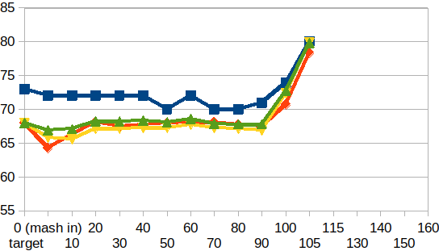
Start Time: 6:45am
Fill mash tun:sat
Fill sparge kettle:sat
Fire burners: 6:45am
Target Temp: 68
Heat Sparge Kettle:
Target Temp: 71
Target Temp (Mash): 68
Grind grain: 7:20am
sparge temp:72
Strike Temp: 68
pump temp: 69
Temp: 64.2
Mash in: 7:45am
Mash: Duration: 90 minutes
Start: 7:45 Finish: 9:15am
Heat (to deactivate enzymes)
Target Temp: 75.5
Start: 9:15am Finish: 9:40am
Heat Sparge H20 (Target75.5◦)
Sparge: Start: 9:45am Finish: 10:23am/10:33
Wort collected: full kettle
Boil : Burner On: 10am Sugar Break Fin/Rolling Boil:11am
Duration: 90 min
Start: 11am Finish: 12:30 pm
Hops In: 11:30 Irish moss in: 12:14 Hops In: 12:15
Chaga tea in: 12:15
Burner Off: 12:31
Rest 15 min
Pump and chill: Start: 12:45 Finish: 1:15
OG : 1.067
Yeast: Nottingham
Notes: pump and chill pretty smooth/ a little hesitant at 1st but got going and held temp well @ 19.8C

